🆆🅴🅻🅲🅾🅼🅴 🆃🅾 🆃🅷🅴

🆆🅴🅱 🅳🅴🆅🅴🅻🅾🅿🅼🅴🅽🆃
DJANGO WEB FRAMEWORK
for perfectionists with deadlines

DAILY AGENDA



The history of Django was created by two web developers Adrian Holovaty and Simon Willison working at the Lawrence Journal-World Newspaper in 2003. It was released publicly as a BSD license in July 2005. The framework was named after guitarist Django Reinhardt.

March 25, 2020

Riyaz Ul Haque
Software Engineer | AWS Developer
Consultadd Inc
Texas : 2300 Valley View Ln. Suite 410,
Irving, TX 75062
WHAT IS WEB FRAMEWORK?
Whenever you type in a URL, your browser makes a request to a server, which will send files — generally HTML — and your browser will process it and display it. At the end of the day, no matter how complicated your web application is, all it does is send files due to a request.
A web framework provides a toolkit of reusable components allowing developers to focus on building their app rapidly without reinventing the wheel.
Django is one of the most popular and huge open-source web frameworks.

WHAT IS DJANGO?
Django is a high-level Python Web framework that encourages rapid development and clean, pragmatic design. Built by experienced developers, it takes care of much of the hassle of Web development, so you can focus on writing your app without needing to reinvent the wheel. It’s free and open source.
Ridiculously fast
- Django was designed to help developers take applications from concept to completion as quickly as possible.
Reassuringly secure
- Django takes security seriously and helps developers avoid many common security mistakes.
Exceedingly scalable
- Some of the busiest sites on the Web leverage Django’s ability to quickly and flexibly scale.

We should use Django in web development because Django is made for rapid-development. It is indeed one of the best features of Django, that backs up by the power it provides to the developer without compromising on any functionality and security issues. All that in the simplest and one of the most powerful languages of the world, Python.

AMAZING FEATURES OF DJANGO?

Excellent Documentation

SEO Optimised

High Scalable

Versatile in Nature

Offers High Security

Thoroughly Tested

Provides Rapid Development

ADVANTAGES & DIS-ADVANTAGES – Why You Should Choose?

ADVANTAGES:

Implemented in Python

Better CDN connectivity and Content Management

Batteries Included Framework

Fast Processing

DIS-ADVANTAGES:

Django is Monolithic

Not for smaller projects

Uses Regular Expression for URLs

COMPANIES USING DJANGO:

Disqus

Instagram

Spotify

BitBucket
- YouTube
- Dropbox
- Mozilla
- Prezi

DJANGO ARCHITECTURE?
For every website on the Internet, there are 3 main components or code partitions; Input Logic, Business Logic, and UI Logic.
Django follows a Model-View-Controller(MVC) architecture, which is split up into three different parts:
- The Model is the logical data structure behind the entire application and is represented by a database(generally relational databases such as MySql, Postgres).
- The View is the user interface — what you see in your browser when you visit a website. These are represented by HTML/CSS/Javascript files.
- The Controller is the middleman that connects the view and model together, meaning that it is the one passing data from the model to the view.

NOTE: Django is mainly an MTV (Model-Template-View) framework. It uses the terminology Templates for Views and Views for Controller.
MODEL ----------------> MODEL DJANGO
VIEW ----------------> TEMPLATE
CONTROLLER ----------------> VIEW

1. Model/ MODEL
The Model is the part of the web-app which acts as a mediator between the website interface and the database. In technical terms, it is the object which implements the logic for the application’s data domain. There are times when the application may only take data in a particular dataset, and directly send it to the view (UI component) without needing any database then the dataset is considered as a model. Although today if we want any kind of website we need to have some sort of database as we must be requiring some user input even if we are creating a simple blog site.
The Model is the component which contains Business Logic in Django architecture.
For example:
When you sign up on any website you are actually sending information to the controller which then transfers it to the models which in turn applies business logic on it and stores in the database.
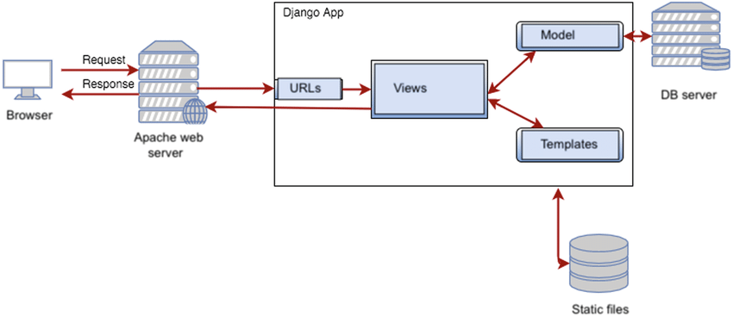
FIGURE: 01

2. View/ TEMPLATE
The view is actually the User Interface of the web-application and contains the parts like HTML, CSS and other frontend technologies. Generally, this UI creates from the Models component, i.e., the content comes from the Models component.
This component contains the UI logic in the Django architecture.
For example:
When you click on any link or interact with the website components, the new webpages that website generates is actually the specific views that stores and generates when we are interacting with the specific components.

3. Controller/ VIEW
The controller as the name suggests is the main control component. What that means is, the controller handles the user interaction and selects a view according to the model. The main task of the controller is to select a view component according to the user interaction and also applying the model component.
This architecture has lots of advantages and that’s why Django is also based on this architecture. It takes the same model to an advanced level.
For example:
When we combine the two previous examples, then we can very clearly see that the component which is actually selecting different views and transferring the data to the model’s component is the controller.

DAY -1
Introduction to Web Development and Django
- What is Frontend, Backend =>
server, an application, and a database.

- and Full-Stack?
Full Stack web development is a combination of both the front-end and back-end. “Stack,” means layer in this case. A full-stack web developer has expertise in all layers of a website’s development. This includes, but not limited to: the server, client and hosting, a form of data structuring or modeling, user interface and experience, as well as the needs of the actual business.
- What is Web Development? => developing an application online that communicates client requests to the server side & returns back to the client after getting the information from the server
- What is a Web Framework?
=> a Web Framework is a collection of reusable toolkits & modules that are always required by most of the python web applications. This saves time & the developer can focus on the application development.

DJANGO
- What is Django?
Django is a python Web Framework
- What are the features of Django?
=> Highly scalable, fast application development, big projects, strict security, SEO optimized, etc.
- What are the advantage and disadvantages? =>Cannot build small projects, monolithic, url uses regular expressions etc
- Who is using Django?
YouTube, Spotify etc.

DJANGO PROJECT SETUP PREREQUISITES
- IDE PyCharm
- VIRTUAL ENVIRONMENT (Virtual Env or Anaconda)
- Installation of Django
- POSTMAN for API testing

DJANGO FIRST PROJECT & APPLICATION SETUP
- First Project
- First Application
- How to RUN SERVER?
- File Layout
- Multiple applications in one project
- Django Architecture
  - Model
  - View
  - Template
- Important files
  - Views.py
  - Models.py
  - Settings.py
  - urls.py

How to Setup a very first project of Django

Python compatibility
Django 2.0 supports Python 3.4, 3.5, 3.6, and 3.7. We highly recommend and only officially support the latest release of each series.
The Django 1.11.x series is the last to support Python 2.7.
There are multiple ways to get started with Django Project setup:
- Setup the Virtual Environment:
- Using Anaconda Package Manager:
  - Create Virtual Environment with or without package installation:
    - $ conda create --name demo_env
    - $ conda create --name demo_env django=2.0
  - Activate Virtual Environment:
    - $ conda activate demo_env
    - $ pip freeze
  - Deactivate Virtual Environment:
    - $ conda deactivate
  - Check Environments available:
    - $ conda info --envs
    - $ conda env list
  - Remove and delete all packages inside:
    - $ conda remove --name demo_env --all

- Using Virtualenv Package Manager:
  - Create Virtual Environment:
    - $ virtualenv demo_env
  - Activate Virtual Environment:
    - $ source demo_env/bin/activate
  - Deactivate Virtual Environment:
    - $ deactivate

- See if Django is installed or not:
- Run any of the following commands:
  - Inside Python Interpreter:
    - $ python
    - >>> import django
    - >>> django.get_version()
  - On Terminal:
    - $ python -m django --version

- Create your FIRST PROJECT in Django:
- Create Directory where you would like to keep your Project files:
  - Keep it on Desktop or anywhere:
    - $ cd Desktop
    - $ mkdir project_code_xyz
    - $ cd project_code_xyz
  - Inside the folder run below command to create django project:
    - $ django-admin startproject name_of_project
    - $ cd name_of_project
  - Run the server to see if everything is working fine:
    - $ python manage.py runserver
    - CONGRATULATIONS
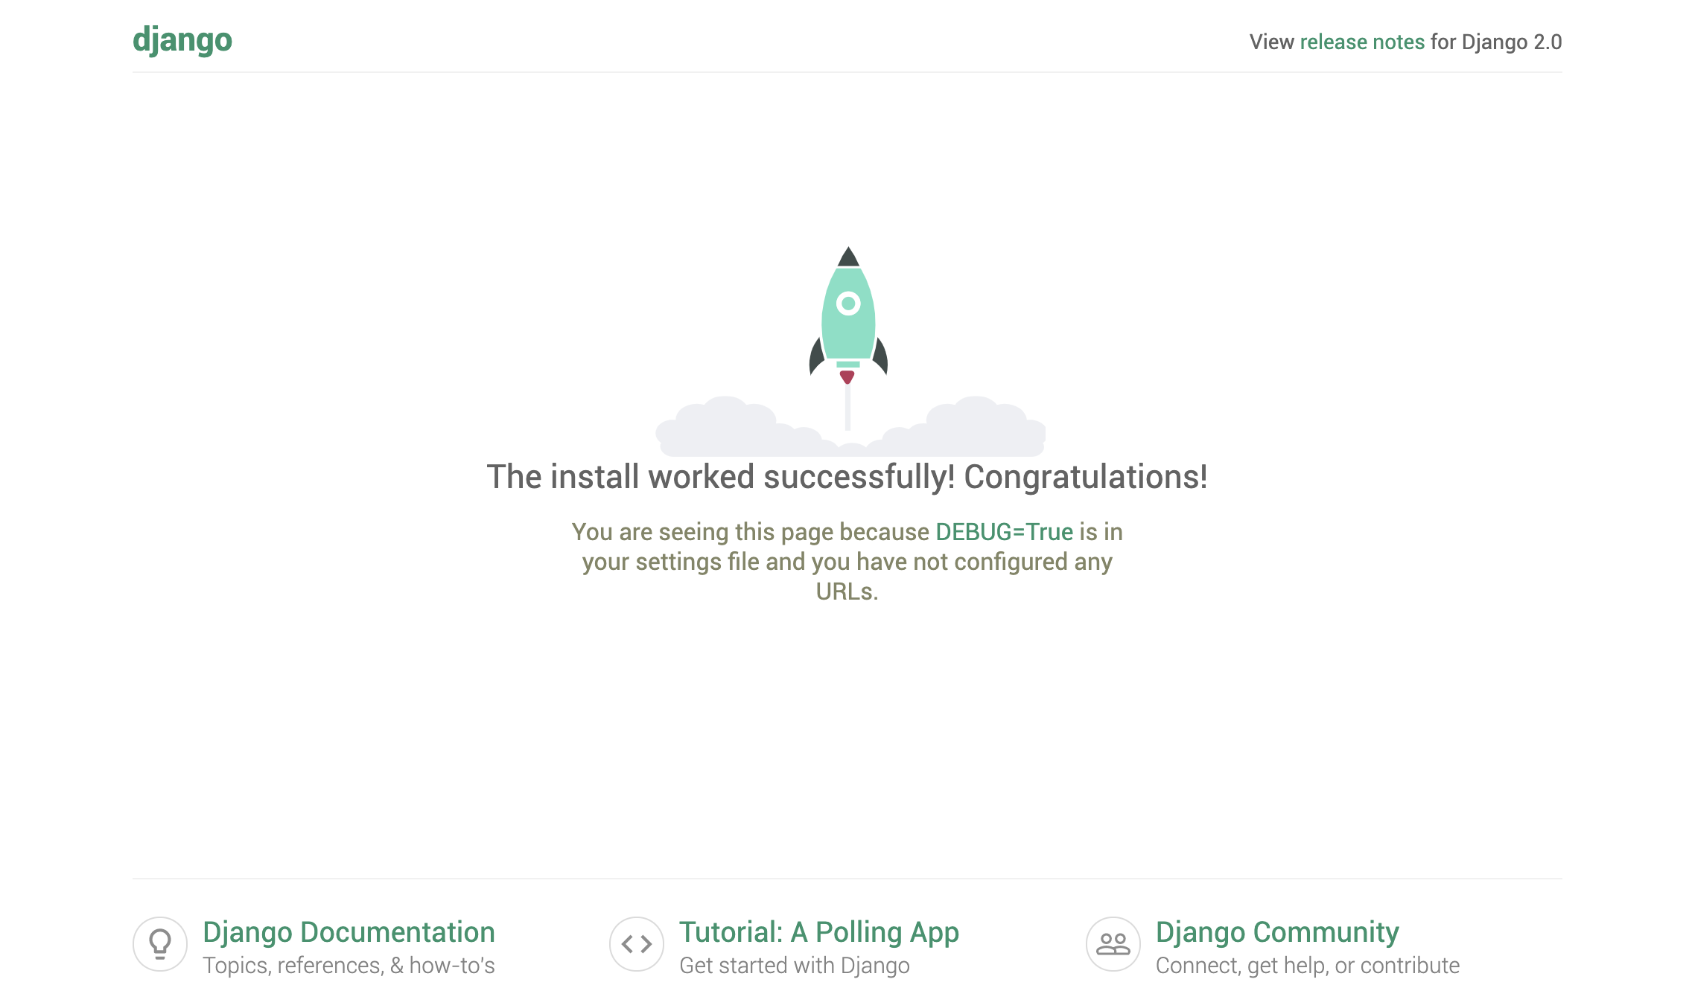
  - Run the server on any other port number:
    - $ python manage.py runserver 0.0.0.0:5050
    - Invalid HTTP_HOST header: '0.0.0.0:5050'. You may need to add '0.0.0.0' to ALLOWED_HOSTS.
    - Go into settings.py and change ALLOWED_HOST=[] to ALLOWED_HOSTS=[“*”]
    - $ python manage.py runserver 0.0.0.0:5050
    - $ python manage.py runserver 0:5050
//Could not run even after //following the commands
- Create your FIRST APPLICATION in Django:
Each application you write in Django consists of a Python package that follows a certain convention. Django comes with a utility that automatically generates the basic directory structure of an app, so you can focus on writing code rather than creating directories.
- Create Application inside Project:
  - Move yourself inside the project directory:
    - $ cd name_of_project
    - $ django-admin startapp name_of_app
  - Keep yourself on top level directory of Project:
    - $ ls It should return manage.py directory
    - $ python manage.py startapp name_of_app
LET'S GET STARTED WITH DJANGO BASICS
1. VIEWS
A view is a “type” of Web page in your Django application that generally serves a specific function and has a specific template. For example, in a blog application, you might have the following views:
- Blog homepage – displays the latest few entries.
- Entry “detail” page – permalink page for a single entry.
- Year-based archive page – displays all months with entries in the given year.
- Month-based archive page – displays all days with entries in the given month.
- Day-based archive page – displays all entries in the given day.
- Comment action – handles posting comments to a given entry.
In Django, web pages and other content are delivered by views. Each view is represented by a Python function (or method, in the case of class-based views). Django will choose a view by examining the URL that’s requested (to be precise, the part of the URL after the domain name).
Now in your time on the web you may have come across such beauties as “ME2/Sites/dirmod.asp?sid=&type=gen&mod=Core+Pages&gid=A6CD4967199A42D9B65B1B”. You will be pleased to know that Django allows us much more elegant URL patterns than that.
A URL pattern is the general form of a URL - for example: /newsarchive/<year>/<month>/.
To get from a URL to a view, Django uses what are known as ‘URLconfs’. A URLconf maps URL patterns to views.

Write your first VIEW:
Let’s write the first view. Open the file demo_app/views.py and put the following Python code in it:
from django.http import HttpResponse
def index(request):
return HttpResponse("Hello Candidates!! Welcome to the DJANGO TRAINING")

This is the simplest view possible in Django. To call the view, we need to map it to a URL - and for this we need a URLconf.
- To create a URLconf in the demo_app directory, create a file called
- Urls.py.
- The next step is to point the root URLconf at the demo_app.urls module. In demo_project/urls.py, add an import for django.urls.include and insert an include() in the urlpatterns list.

from django.contrib import admin
from django.urls import include, path

urlpatterns = [
path('training/', include('demo_app.urls')),
path('admin/', admin.site.urls),
]

- The include() function allows referencing other URLconfs. Whenever Django encounters include(), it chops off whatever part of the URL matched up to that point and sends the remaining string to the included URLconf for further processing.
- The idea behind include() is to make it easy to plug-and-play URLs.

IMPORTANT:
The path() function is passed four arguments, two required: route and view, and two optional: kwargs, and name. At this point, it’s worth reviewing what these arguments are for.

path() argument: route
route is a string that contains a URL pattern. When processing a request, Django starts at the first pattern in urlpatterns and makes its way down the list, comparing the requested URL against each pattern until it finds one that matches.
Patterns don’t search GET and POST parameters, or the domain name.
For example, in a request to
- https://www.example.com/demo_app/, the URLconf will look for demo_app/.
- https://www.example.com/demo_app/?page=3, the URLconf will also look for demo_app/.

path() argument: view
When Django finds a matching pattern, it calls the specified view function with an HttpRequest object as the first argument and any “captured” values from the route as keyword arguments. We’ll give an example of this in a bit.

2. MODELS
Write your first MODEL:
A model is the single, definitive source of information about your data. It contains the essential fields and behaviors of the data you’re storing. Generally, each model maps to a single database table.

- Each model is a Python class that subclasses django.db.models.Model.
- Each attribute of the model represents a database field.
- With all of this, Django gives you an automatically-generated database-access API; Making queries.

from django.db import models

class Candidate(models.Model):
First_name = models.CharField(max_length=30)
Last_name = models.CharField(max_length=30)
Email_Id= models.CharField(max_length=30)

First_name, Last_name and Email_Id are fields of the model. Each field is specified as a class attribute, and each attribute maps to a database column

The above Candidate model would create a database table like this:
CREATE TABLE demo_app_Candidate (
"id" serial NOT NULL PRIMARY KEY,
"First_name" varchar(30) NOT NULL,
"Last_name" varchar(30) NOT NULL,
"Email_Id" varchar(30) NOT NULL
);
.
Some technical notes:
- The name of the table, demo_app_Candidate, is automatically i from some model metadata but can be overridden.
- An id field is added automatically, but this behavior can be overridden.
- The CREATE TABLE SQL in this example is formatted using PostgreSQL syntax, but it’s worth noting Django uses SQL tailored to the database backend specified in your settings file.
Once you have defined your models, you need to tell Django you’re going to use those models. Do this by editing your settings file and changing the INSTALLED_APPS setting to add the name of the module that contains your models.py.
INSTALLED_APPS = [
#...
'demo_app',
#...
]
When you add new apps to INSTALLED_APPS, be sure to run manage.py migrate, optionally making migrations for them first with manage.py makemigrations.

IMPORTANT:
Migrations are Django’s way of propagating changes you make to your models (adding a field, deleting a model, etc.) into your database schema. They’re designed to be mostly automatic, but you’ll need to know when to make migrations, when to run them, and the common problems you might run into.

The Commands
There are several commands which you will use to interact with migrations and Django’s handling of database schema:
- migrate, which is responsible for applying and unapplying migrations.
- makemigrations, which is responsible for creating new migrations based on the changes you have made to your models.
- showmigrations, which lists a project’s migrations and their status.

You should think of migrations as a version control system for your database schema. makemigrations is responsible for packaging up your model changes into individual migration files - analogous to commits - and migrate is responsible for applying those to your database.

3. DATABASE SETUP
By default, the configuration uses SQLite. If you’re new to databases, or you’re just interested in trying Django, this is the easiest choice.
If you wish to use another database, install the appropriate database bindings and change the following keys in the DATABASES 'default' item to match your database connection settings:
If you’re using a database besides SQLite, make sure you’ve created a database by this point. Do that with “CREATE DATABASE database_name;” within your database’s interactive prompt. Let’s say ca2020django
Also make sure that the database user provided in demo_project/settings.py has “create database” privileges. This allows automatic creation of a test database.
Settings would look like this:
DATABASES = {
'default': {
'ENGINE': 'django.db.backends.mysql',
'NAME': 'ca2020django',
'USER': 'root',
'PASSWORD': 'password',
'HOST': 'localhost',
'PORT': '3306',
}
}

After that run the following commands to replicate the models changes to newly connected database:
- $ pip install mysqlclient
- $ python manage.py makemigrations
- $ python manage.py migrate
NOTE: $ python manage.py check this checks for any problems in your project without making migrations or touching the database.

4. TEMPLATE
The page’s design is hard-coded in the view. If you want to change the way the page looks, you’ll have to edit this Python code. So let’s use Django’s template system to separate the design from Python by creating a template that the view can use.
STEPS:
- It is good to create a template directory on your project level or either application level.
- Make sure to create a template directory and within that create an individual application directory like demo_app.
- This is called namespacings - We need to be able to point Django at the right one, and the best way to ensure this is by namespacing them

Template namespacing
Now we might be able to get away with putting our templates directly in demo_app/templates (rather than creating another demo_app subdirectory), but it would actually be a bad idea. Django will choose the first template it finds whose name matches, and if you had a template with the same name in a different application, Django would be unable to distinguish between them. We need to be able to point Django at the right one, and the best way to ensure this is by namespacing them. That is, by putting those templates inside another directory named for the application itself.

Directory Structure may look like this:
- Demo_Project
  - Demo_Project
    - …………
    - Demo_app
    - …………
  - templates
    - Demo_app
      - Index.html
      - Payment.html
      - Dashboard.html

Configuration with Demo_Project’s settings.py:
# Build paths inside the project like this: os.path.join(BASE_DIR, ...)
BASE_DIR= os.path.dirname(os.path.dirname(os.path.abspath(__file__)))
TEMPLATE_DIR = os.path.join(BASE_DIR,'template')

TEMPLATES = [
{
'BACKEND': 'django.template.backends.django.DjangoTemplates',
'DIRS': [TEMPLATE_DIR,],
'APP_DIRS': True,
'OPTIONS': {
'context_processors': [
'django.template.context_processors.debug',
'django.template.context_processors.request',
'django.contrib.auth.context_processors.auth',
'django.contrib.messages.context_processors.messages',
],
},
},
]

4. STATIC FILES
Aside from the HTML generated by the server, web applications generally need to serve additional files — such as images, JavaScript, or CSS — necessary to render the complete web page. In Django, we refer to these files as “static files”.
For small projects, this isn’t a big deal, because you can keep the static files somewhere your web server can find it. However, in bigger projects – especially those comprised of multiple apps – dealing with the multiple sets of static files provided by each application starts to get tricky.
NOTE: That’s what django.contrib.staticfiles is for: it collects static files from each of your applications (and any other places you specify) into a single location that can easily be served in production.

Customize your app’s look and feel
STEPS:
- It is good to create a static directory on your project level or either application level.
- Make sure to create a static directory and within that create an individual application directory like demo_app.
Directory Structure may look like this:
- Demo_Project
  - Demo_Project
    - …………
    - Demo_app
    - …………
  - static
    - Demo_app
      - Images
        - main.jpeg
        - logo.png
      - style.css
      - Payment.css

Configuration with Demo_Project’s settings.py:
# Build paths inside the project like this:
STATIC_URL = '/static/'
STATICFILES_DIRS = [
os.path.join(BASE_DIR, "static"),
]

IMPORTANT:

Serving static files in production

Serving the site and your static files from the same server

Serving static files from a dedicated server - CORS

Serving static files from a cloud service or CDN

HOW TO DEVELOP APIs WITH DJANGO REST FRAMEWORK WITH TDD
https://www.django-rest-framework.org/
https://www.django-rest-framework.org/tutorial/quickstart/

Django REST framework is a powerful and flexible toolkit for building Web APIs. -
REST APIs are used in every application or piece of software to connect the backend and frontend parts.
Some reasons you might want to use REST framework:
- The Web browsable API is a huge usability win for your developers.
- Authentication policies including packages for OAuth1a and OAuth2.
- Serialization that supports both ORM and non-ORM data sources.
- Customizable all the way down - just use regular function-based views if you don't need the more powerful features.
- Extensive documentation, and great community support.
- Used and trusted by internationally recognised companies including Mozilla, Red Hat, Heroku, and Eventbrite.

The Step-by-Step Guide To Your API

Set up your development environment
First of all, you have to install Python dependencies for your OS. If you’re using Windows, you can easily install Linux as your secondary OS using this manual or VirtualBox.
To proceed, use pyenv, a simple yet effective Python management tool. It’s our go-to helper. It allows us to change the global Python version, install multiple Python versions, set project-specific Python versions, and manage virtual Python environments.
If you’re using Mac OS or Linux, it should be easy to install:
- $ git clone https://github.com/pyenv/pyenv.git ~/.pyenv
Define the environment variable PYENV_ROOT to point to the path where pyenv repo is cloned. Then, add $PYENV_ROOT/bin to your $PATH for access to the pyenv command-line utility.
- $ echo 'export PYENV_ROOT="$HOME/.pyenv"' >> ~/.bashrc
- $ echo 'export PATH="$PYENV_ROOT/bin:$PATH"' >> ~/.bashrc
Add the pyenv unit to your shell to enable shims and autocompletion.
- $ echo -e 'if command -v pyenv 1>/dev/null 2>&1; then\n eval "$(pyenv init -)"\nfi' >> ~/.bashrc
Restart your shell so the path changes take effect. Now, you can begin to use pyenv.
- $ exec "$SHELL"
At this point, install the latest stable version of Python. Now this…
- $ ç
… and create an environment for your project.
- $ pyenv virtualenv 3.7.4 blog

Create a Django Project
Now, we’ll create a project folder and navigate to the newly created directory.
- $ mkdir projects && cd projects
The next step is to create a Django project. There are several ways to do it.
Personally, I prefer to start projects from a template and use the Django Stars backend skeleton that has been implemented in our web development company. It’s a great tool, since…
- Django projects are formatted according to the Django Stars Code Style requirements,
- django-environ helps keep all configuration in the environment,
- psycopg2 is the default database driver,
- django-extensions/ipython/ipdb is used for debug purposes,
- pytest with pylava are provided for testing, and
- A redefined startapp command allows you to create apps according to Django Stars Code Style requirements.
Here’s the command that will help you start a project from a template:
- $ curl https://be.skeletons.djangostars.com/startproject | bash
At the start, you will be offered several Python versions to work with. Select the 3.7 version of Python.
- At the start, you will be offered several Python versions to work with. Select the 3.7 version of Python.
- Set the project name to django_blog.
- Since we’re going to use the Django Rest Framework, we should select the 3rd option:
- Let’s now navigate to the project name directory:
  - $ cd django_blog

PROJECT STRUCTURE
django_blog
├── api
│ ├── django_blog
│ │ ├── apps
│ │ │ ├── account
│ │ │ │ ├── admin.py
│ │ │ │ ├── apps.py
│ │ │ │ ├── forms.py
│ │ │ │ ├── __init__.py
│ │ │ │ ├── managers.py
│ │ │ │ ├── migrations
│ │ │ │ │ ├── 0001_initial.py
│ │ │ │ │ └── __init__.py
│ │ │ │ └── models.py
│ │ │ ├── common
│ │ │ │ ├── apps.py
│ │ │ │ ├── __init__.py
│ │ │ │ ├── management
│ │ │ │ │ ├── commands
│ │ │ │ │ │ ├── generate_secretkey.py
│ │ │ │ │ │ ├── __init__.py
│ │ │ │ │ │ └── startapp.py
│ │ │ │ │ └── __init__.py
│ │ │ │ └── models
│ │ │ │ ├── core.py
│ │ │ │ └── __init__.py
│ │ │ └── __init__.py
│ │ ├── __init__.py
│ │ ├── settings
│ │ │ ├── contrib.py
│ │ │ ├── django_blog.py
│ │ │ ├── django.py
│ │ │ ├── environment.py
│ │ │ └── __init__.py
│ │ ├── urls.py
│ │ └── wsgi.py
│ ├── Makefile
│ ├── manage.py
│ ├── pylama.ini
│ ├── pyproject.toml
│ ├── pytest.ini
│ └── requirements
│ ├── common.in
│ ├── common.txt
│ ├── dev.in
│ └── dev.txt
├── build
│ ├── ci
│ │ └── circle.yml
│ ├── docker-compose-api.yml
│ ├── docker-compose-dev.yml
│ ├── docker-entrypoint-api.sh
│ └── Dockerfile.api
├── circle.yml -> build/ci/circle.yml
└── README.md

Install packages with requirements
To run the project, we need to install some packages, which are defined in the requirements/dev.txt.
Thus, we install packages with requirements for local development.
Navigate to the API directory:
- $ cd api
and install the dependencies.
If you need to add any other packages, just add your package to the dev.txt file for local development, or to common.txt if you need it to be installed on the server.
Next, we will have to add the Pillow package that isn’t included by default in the package we installed. Open the
requirements/common.txt file and add Pillow==6.1.0 to the end. Then run:
- $ pip install -r requirements/dev.txt
This is the file that contains a list of all the packages that will be installed.

Bootstrap the Database
Our project needs a database. Most Django developers prefer to use PostgresQL for all environments – i.e., the, development, staging and production systems. Some people use SQLite for local development and PostgreSQL in production. Django ORM allows you to deal with both databases. I strongly recommend that you keep your development station and production as similar as possible and use the same database.
There are several ways to bootstrap a database:
- Using SQLite
To make the database bootstrapping easier, we can use SQLite. It’s an in-process library that implements a self-contained, serverless, zero-configuration, transactional SQL database engine.
All you need to do is open the .env file and replace:
- DJANGO_BLOG_DATABASE_URL=psql://django_blog@127.0.0.1:5432/django_blog
With
- DJANGO_BLOG_DATABASE_URL=sqlite:///db.sqlite3
Here, we use the django-environ package, which allows you to define the configuration depending on your environment. You can find out more about this approach through The Twelve Factor App.
- Using PostgreSQL
PostgreSQL is a powerful, open-source object-relational database system. It uses and extends the SQL language, and has many features that allow you to safely store and scale the most complicated data workloads. This system is a bit more complicated than SQLite, so you might want to learn more about it.
It’s much easier to install PostgreSQL with Docker – an open-source tool that automates the deployment of an application inside a software container. If you’re not familiar with Docker yet, feel free to check out some instructions on how to install it and work with docker-compose.
Then just open a new tab and run:
- $ docker-compose -f build/docker-compose-dev.yml up
Next, we should apply initial migrations:
- $ python manage.py migrate
This will apply all previously unapplied migrations to the database which comes with the Django installation.
https://github.com/olegkovalov/django_blog/commit/4f9b20bafc69fb686026d112592c549bd8b6e858

Create a Blog Application
At this point, we’ve already created a Django project, installed packages with requirements, and bootstrapped the database. Which means we can now finally create a blog application using the following command:
- $ python manage.py startapp blog
By doing this, you’ve also created a new directory. It will be available in apps/blog.
Now, we should register our application in ‘INSTALLED_APPS’.
Add ’blog’ to your ‘INSTALLED_APPS’ settings placed in ‘api/django_blog/settings/django.py’
INSTALLED_APPS = [
....
# our apps
"django_blog.apps.common.apps.CommonConfig",
"django_blog.apps.account.apps.AccountConfig",
"django_blog.apps.blog.apps.BlogConfig",
"blog"
]

Test-Driven Development (TDD) of APIs
As you may have already learned, test-driven development is an approach that focuses on writing tests before you start implementing the business logic of your application. Writing tests first requires you to really consider what do you want from the code. But apart from this, TDD has numerous other benefits:
- Fast feedback and detailed specification;
- Reduced time spent on reworking and time spent in the debugger;
- Maintainable, flexible, and easily extensible code;
- Shorter development time to market;
- Increased developer’s productivity;
- SOLID code; and
- A clean interface.
Also, TDD tells you whether your last change (or refactoring) broke previously working code. Moreover, it forces radical simplification of the code – you will only write code in response to the requirements of the tests. Also, you’re forced to write small classes focused on one thing only. Further on, it allows the design to evolve and adapt to your changing understanding of the problem.
The resulting unit tests are simple and act as documentation for the code. Since TDD use cases are written as tests, other developers can view the tests as examples of how the code is supposed to work.
Before we write tests for our API, let’s take a step back and look at HTTP and how it interacts with the Django REST Framework.
The Hypertext Transfer Protocol (HTTP) is an application protocol for distributed, collaborative, hypermedia information systems. HTTP defines methods like GET, POST, PUT, DELETE, OPTIONS, and HEAD to indicate the desired action that should be performed on the resource you identify. These methods can be defined by the characteristics of safety and idempotency (you can find out more about this here). By agreement, REST APIs rely on these methods, so feel free to use the appropriate HTTP method for each type of action.
Let’s apply it to the resource ‘post’.

Endpoint | HTTP Method | CRUD Method | Result
posts/ | GET | READ | Get all posts
posts/ | POST | CREATE | Create new post
posts/:id | GET | READ | Get post details
posts/:id | PUT | UPDATE | Update post
posts/:id | PATCH | UPDATE | Partial update of post
posts/:id | DELETE | DELETE | Delete post
posts/:id | OPTIONS |  | Return supported HTTP methods

UNITEST — Unit testing framework
The unittest unit testing framework was originally inspired by JUnit and has a similar flavor as major unit testing frameworks in other languages. It supports test automation, sharing of setup and shutdown code for tests, aggregation of tests into collections, and independence of the tests from the reporting framework.
To achieve this, unittest supports some important concepts in an object-oriented way:
- test fixture
  - A test fixture represents the preparation needed to perform one or more tests, and any associated cleanup actions. This may involve, for example, creating temporary or proxy databases, directories, or starting a server process.
- test case
  - A test case is the individual unit of testing. It checks for a specific response to a particular set of inputs. unittest provides a base class, TestCase, which may be used to create new test cases.
- test suite
  - A test suite is a collection of test cases, test suites, or both. It is used to aggregate tests that should be executed together.
- test runner
  - A test runner is a component which orchestrates the execution of tests and provides the outcome to the user. The runner may use a graphical interface, a textual interface, or return a special value to indicate the results of executing the tests.

DJANGO ORM(Object-Relational Mapping)
https://books.agiliq.com/projects/django-orm-cookbook/en/latest/introduction.html

Django ORM is one of the key pillars of Django. It provides abstractions to work with databases, in a mostly database agnostic way. Django ORM combines ease of use with powerful abstractions. It keeps “Simple things easy and hard things possible”.

“Once you’ve created your data models, Django automatically gives you a database-abstraction API that lets you create, retrieve, update and delete objects.”

What is an ORM?
ORM is an acronym for the object-relational mapper. The ORM’s main goal is to transmit data between a relational database and application model. The ORM automates this transmission, such that the developer need not write any SQL.
ORM, as from the name, maps objects attributes to respective table fields. It can also retrieve data in that manner.

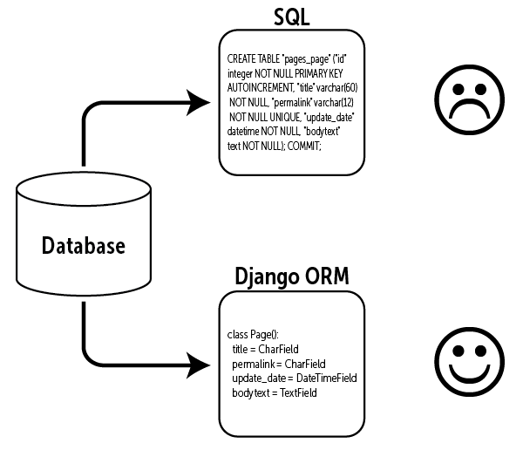
FOR EXAMPLE:
Sometimes you want to know how a Django ORM makes our queries execute or what is the corresponding SQL of the code you are writing. This is very straightforward. You can get str of any queryset.query to get the sql.
You have a model called Event. For getting all records, you will write something like Event.objects.all(), then do str(queryset.query)

>>> queryset = Event.objects.all()
>>> str(queryset.query)
SELECT "events_event"."id", "events_event"."epic_id",
"events_event"."details", "events_event"."years_ago"
FROM "events_event"

